Sean Higgins

October 6, 2017

CS 562 – Adv. Real-Time Graphics

Prof. Herron

CS 562 Adv. Real-Time Graphics – Proj. 1 Report

Overview:

After some constant refactoring and tweaking to previous years’ projects, I was swiftly able to shift from the forward rendering format to a deferred shading format, simply updating the FBO object abstraction to use additional textures in order to be used easily as a g-buffer.

G-Buffer:

The core of deferred shading is the g-buffer, or geometry buffer, which is created in the very first rendering pass of the algorithm. Instead of using the depth test in every single pass—effectively wasting per-pixel calculations when a single pixel has multiple objects at different depths—we only use the depth test when we need it, and we instead store the various values required for lighting calculations into textures, reading them out when we need to use them. This allows us to not only save on various calculations, but we can also perform various preprocessing steps on some of these values in order to get various other effects!

Local Lighting:

The use of the g-buffer and these values with already known depth lets us use some additional tricks with regards to local lights. Since we already know where in the world space the pixels will correspond to, we can approximate small, local lights very easily. Simply modeling them as a sphere, we can very easily do a simple distance check to see if a given world-point is within the range of the local light. If it is, we add the local light’s contribution to the output pixel. If it isn’t, we don’t do anything. It is a very simple addition to make, and for almost no cost. I have currently been able to add up to a thousand lights and still have everything be in real-time with only slight drops in framerate.

G-Buffer Values

Diffuse:

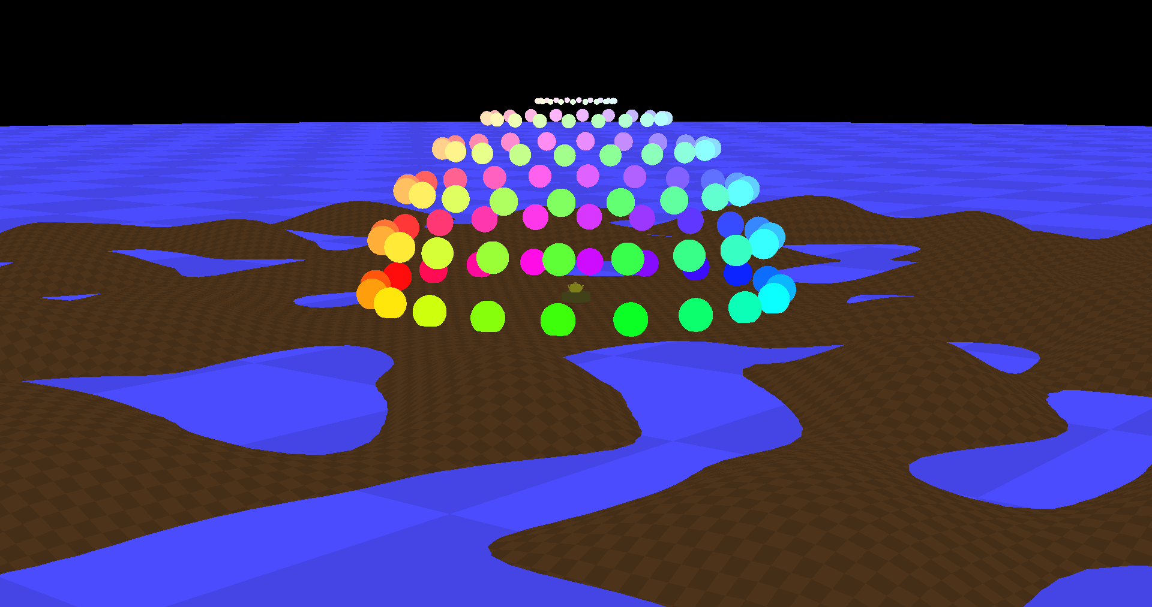

Specular:

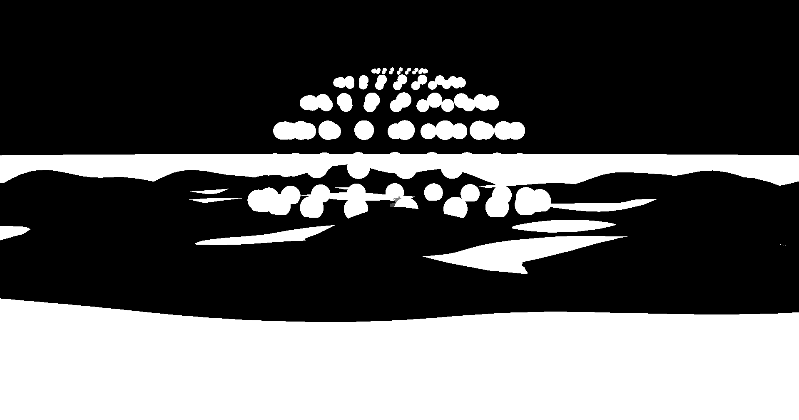

Normal:

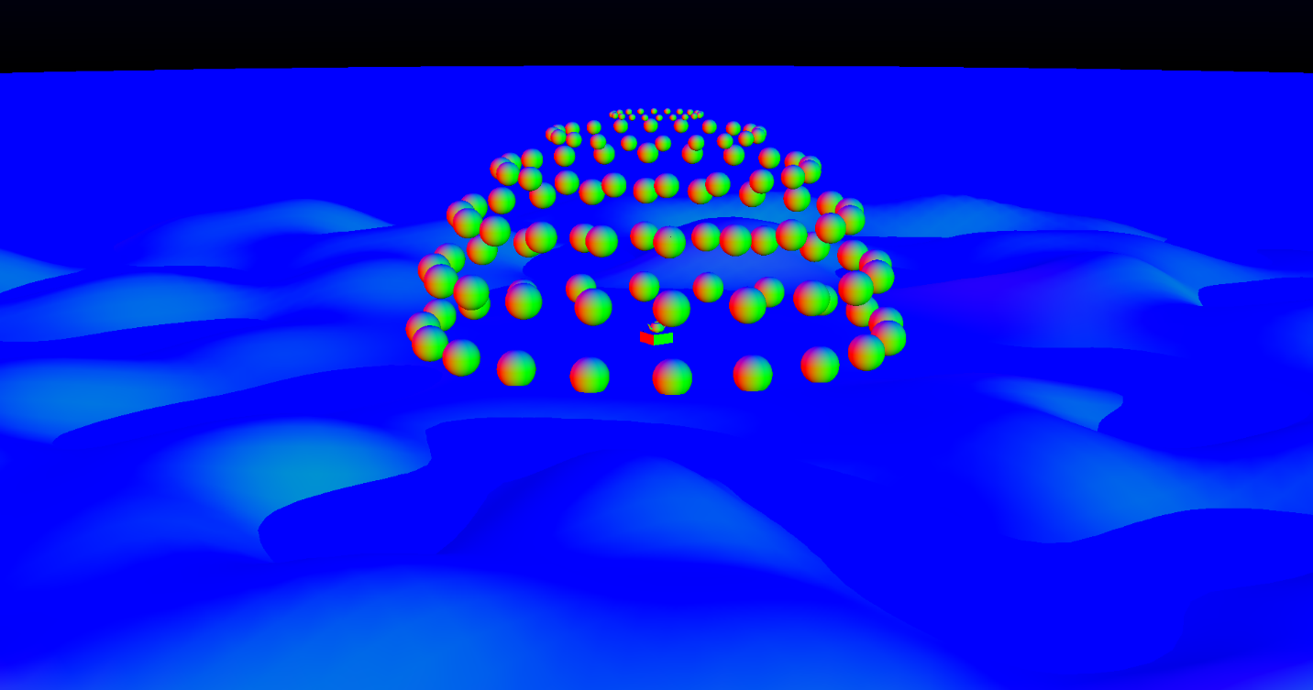

World Position:

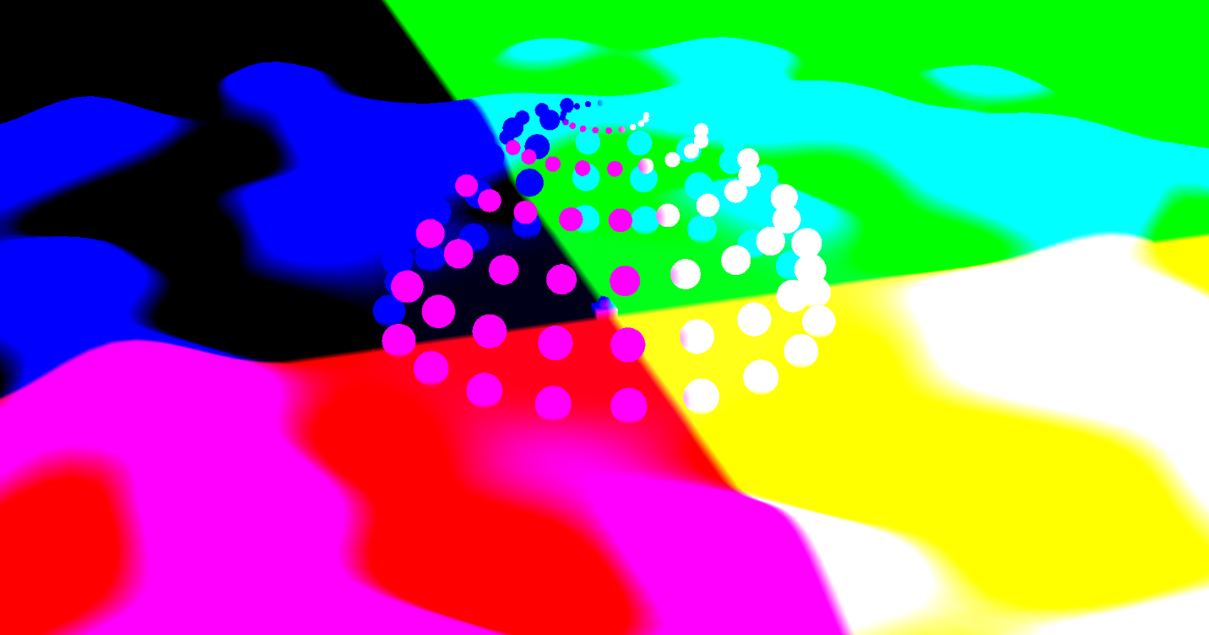

Global Lighting: Note- some aspects of the local lighting can also be seen

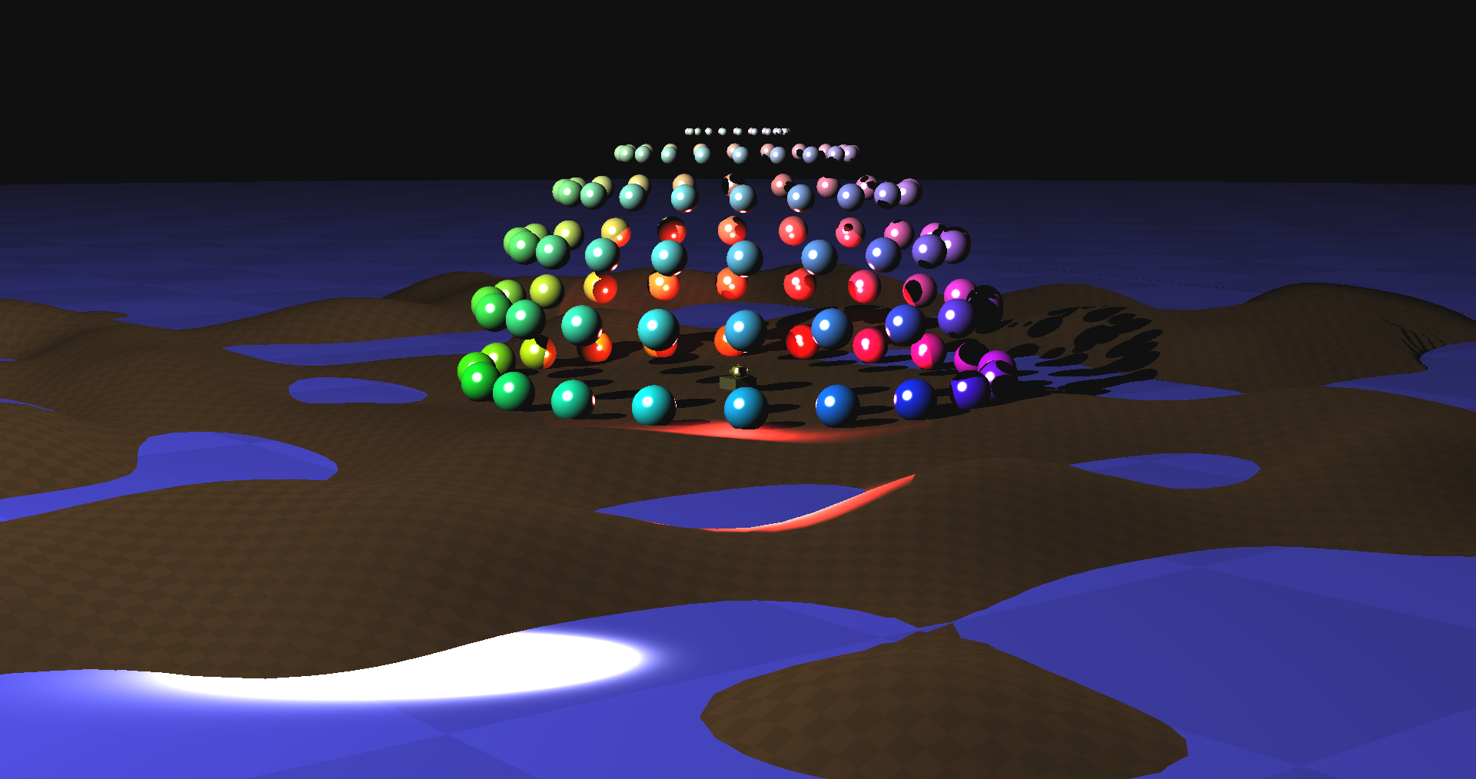

Local Lighting: Note – the black is from the global lighting shadow-map back clipping plane

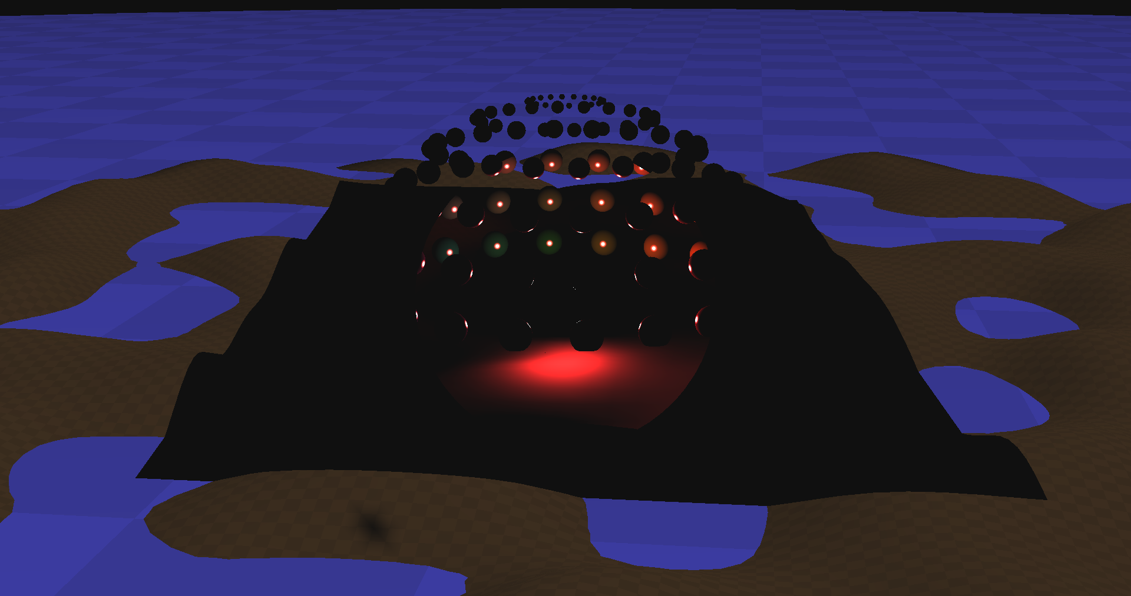

Many, many Local Lights:

